Algorithms for Phylogenetic Footprinting
Mathieu Blanchette, Benno Schwikowski, and Martin Tompa
Journal of Computational Biology, Vol. 9, Number 2, pp.211-223, 2002
- Introduction
Phylogenetic footprinting is a technique that identifies regulatory elements by finding unusually well conserved regions in a set of orthologous non-coding DNA sequences from multiple species.
- The substring parsimony problem
2.1 A dynamic programming algorithm
Inputs :
A set of orthologous sequences S₁,…,S_{n} from n different species.
The phylogenetic tree T relating these species.
The length k of the motifs to look for.
An integer d.

Outputs :
All sets of substrings s₁,…,s_{n} of S₁,…,S_{n} respectively, each of length k, such that the parsimony score of s₁,…,s_{n} on T is at most d.
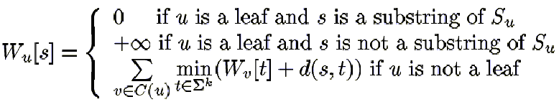

2.2 Improved algorithm
An auxiliary table X_{(u,v)} for each edge (u,v) in the tree, where u is the parent of v.
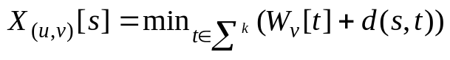
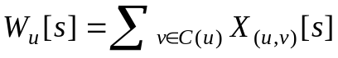
a set of sequence B_{p}, called the boundary, which contains exactly the sequences s such that 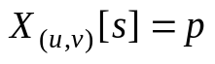.
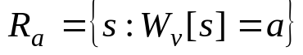
Let 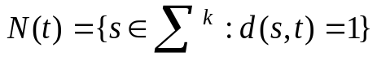 be the set of neighbors of string t.
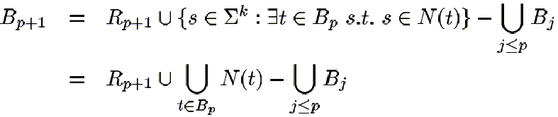
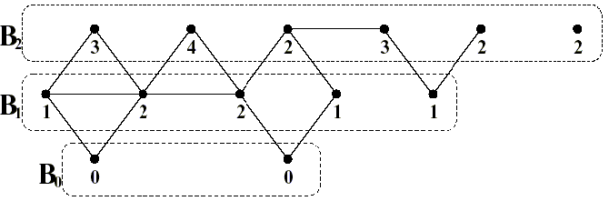
  - Sibling bounds
  - Parent bounds
  - Filtering substrings
Reduce the computation time by avoiding the computation of useless entries in W and X tables.
When v is not a leaf, let y be an arbitrary leaf in the subtree rooted at v. Then X_{(u,v)}[s] <= d implies that s must have Hamming distance at most d to some substring of S_{y}, which in turn implies that X_{(x,y)}[s] <= d. This means that X_{(u,v)} has no more entries than X_{(x,y)}, which we showed is O(l•(3k)^{d}) Many entries X_{(u,*)}[s] end up being rejected because they add up to more than d. To avoid that situation, we are going to compute the entries of the X_{(u,*)} tables in parallel.
  - General edit-distance metric
We can allow substitutions, insertions, and deletions, instead of only substitutions. The complexity of the resulting algorithm would not be that mentioned above, but would be a rather complex expression.
  - Reporting solutions
When the input sequences contain a conserved region that is much longer than k, in which case all length k substrings of the conserved region would be reported. If two sets of substrings overlap in exactly the same manner in each of the n input sequences, these substrings will be merged and displayed as only one solution.
- Conclusion and future work
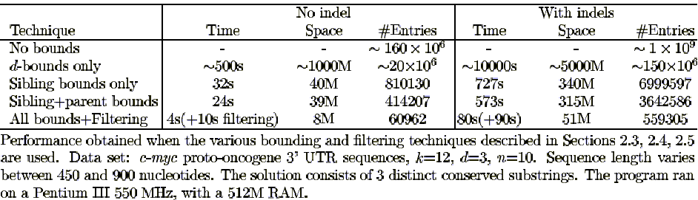

Created by : Jih-Wei Huang
Date : Nov. 29, 2002

